Q1 Retrieve the total number of orders placed.

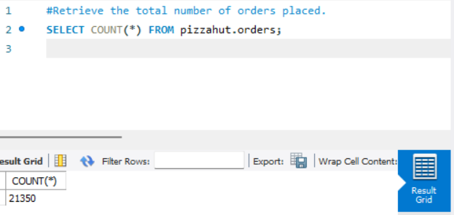

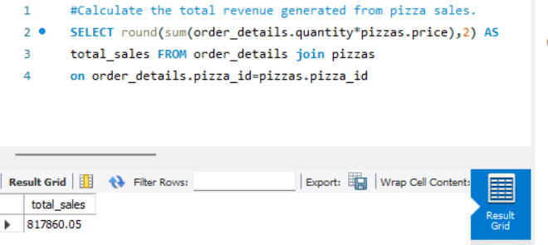Q2. Calculate the total revenue generated from pizza sales.

Q3. Identify the highest priceed pizza.

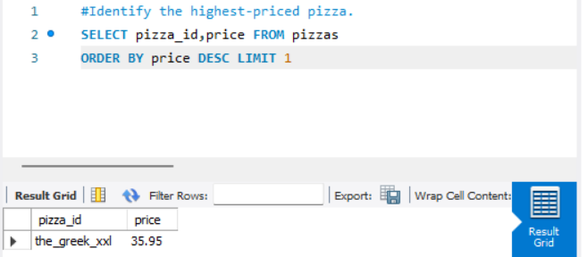

Q4.Identify the most common pizza size ordered.

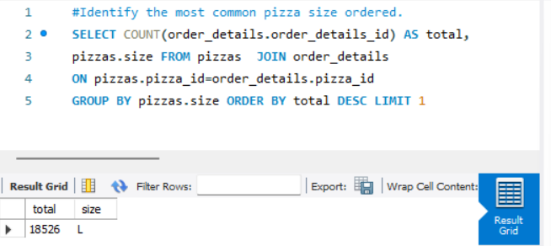

Q5.List the top 5 most ordered pizza types along with their quantities.

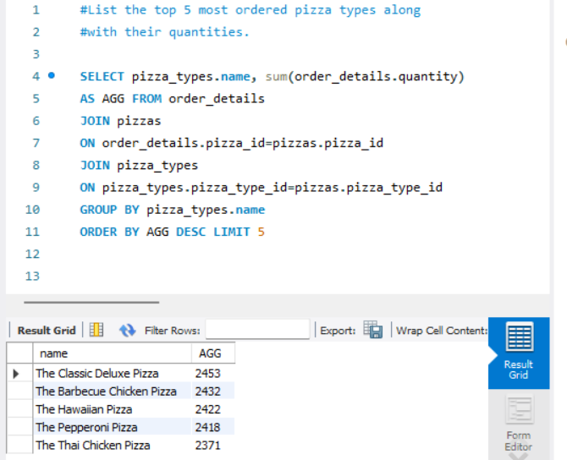

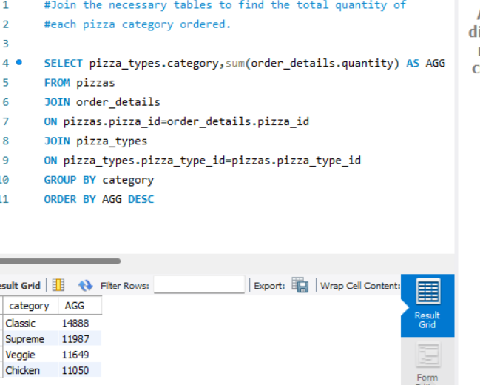

Q6. Join the necessary tables to find the total quantity of each pizza category ordered.

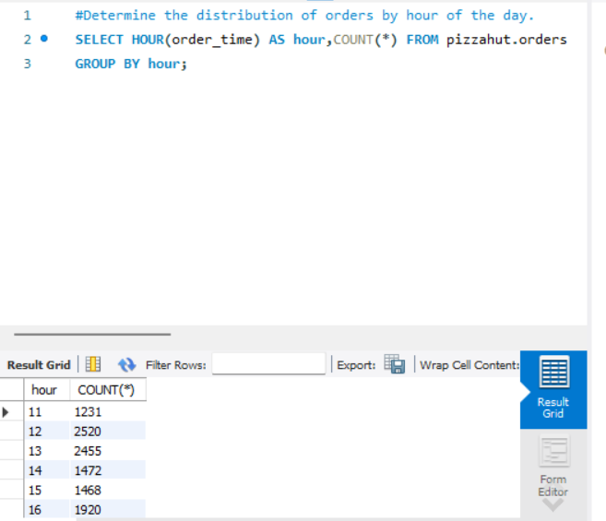Q7. Determine the distribution of orders by hour of day.

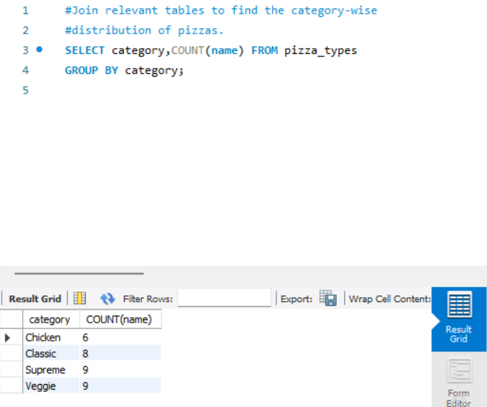

Q8. Join relevant tables to find the category wise distribution of pizzas.

Q9. Group the orders by date and calculate the average number of pizzas ordered per day.

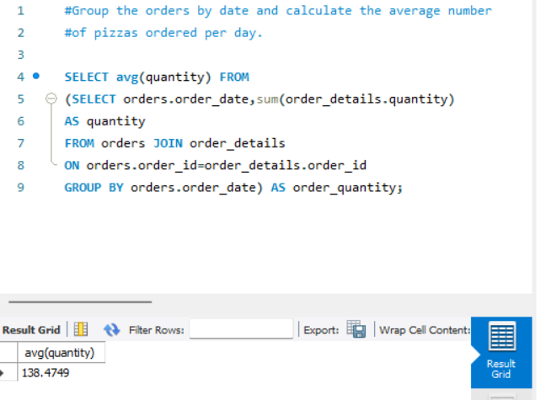

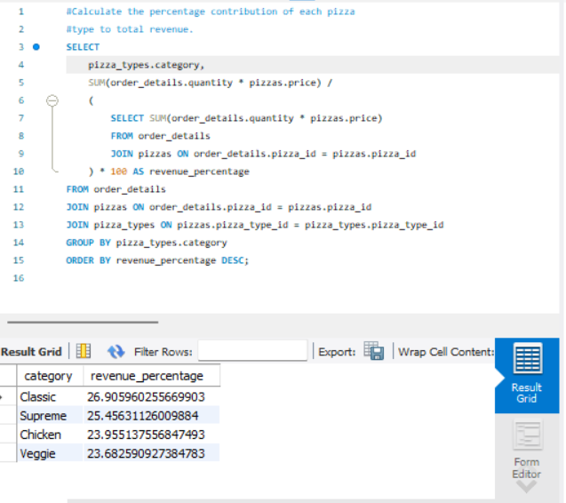

Q10. Calculate the percentage contribution of each pizza type in total revenue.

Q 11. Analyse the cumulative revenue generated over time.

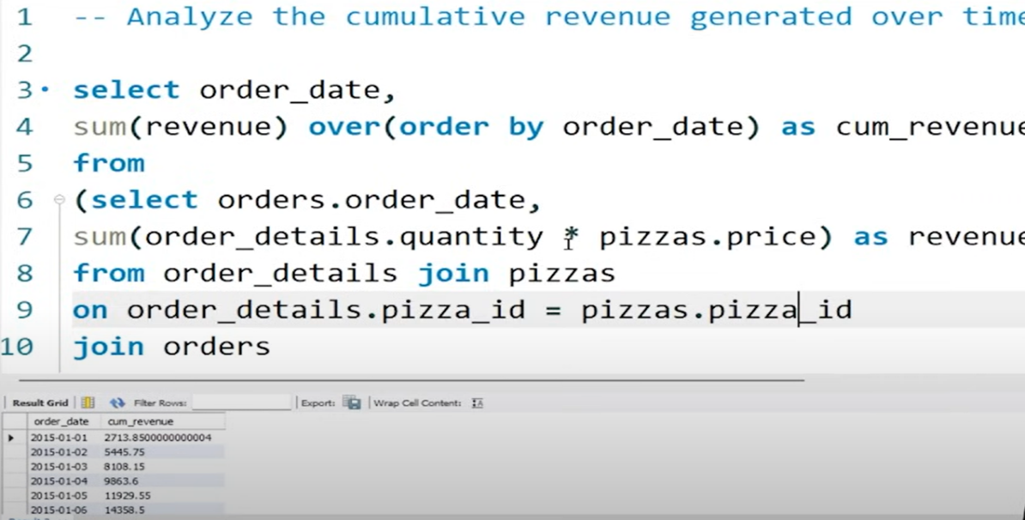

Q 12. Determine the top 3 most ordered pizza types based on revenue for each pizza category .

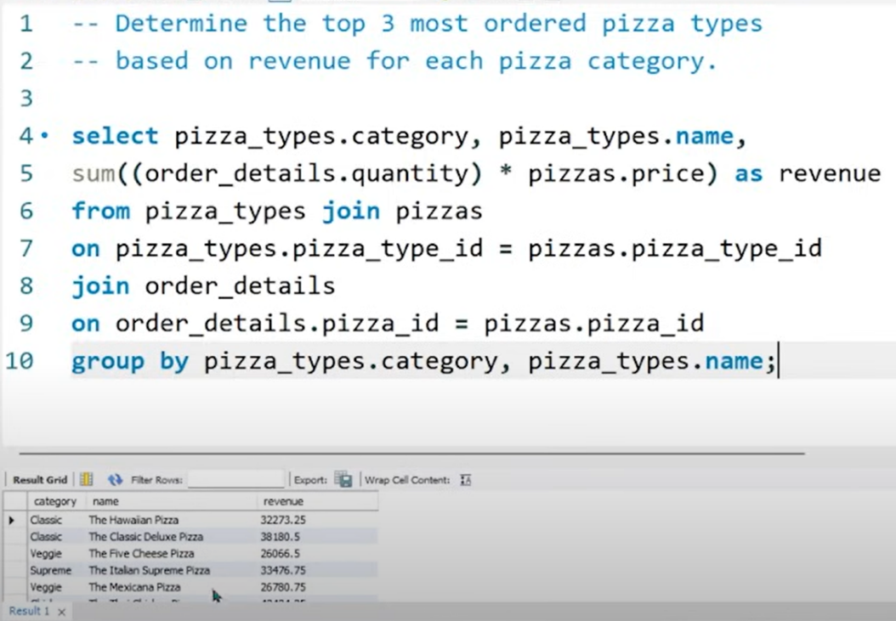

Q13. Determine the top 3 most ordered pizza types base on revenue.

